Specification of Phone Book Management System

Group 5
- Phone Book Management system

The Phone Book Management System allows users to manage their personal contacts efficiently and securely. The system supports two types of users: Member and Admin, each with distinct roles and permissions.
- Main Functional Requirments

1. Member Functions
- Add Contact:
Members can add a new contact with details such as Name, Phone Number, Email, Address, and Notes.
- Edit Contact:
Members can edit information of existing contacts.
- Delete Contact:
Members can delete one or more contacts from their personal contact list.
- Search Contacts:
Members can search for contacts by Name, Phone Number, Email, or other criteria.
- Contact Groups:
Members can categorize contacts into groups such as Family, Friends, Work for better organization.
- View Recent Contacts:
Displays contacts recently viewed or modified by the member.

2. Admin Functions
- Member Account Management:
Admins can view member lists, create new accounts, reset passwords, or deactivate users.
- Monitor System Data:
Admins can track total contacts, monitor system storage.
- Manage Access Rights:
Admins can adjust user permissions or upgrade member accounts.
- Non-Functional Requirements

2.1. Performance & Scalability
These requirements define how fast and efficient the system must be under load.
- 2.1.1. Response Time:
  - The system must load the main dashboard (contact list) in under 1.5 seconds on a standard broadband connection.
  - Search queries executing against a database of up to 10,000 contacts must return results in under 500 milliseconds.
  - Login authentication must be processed in under 1 second.
- 2.1.2. Concurrency:
  - The system must support at least 50 concurrent users (active simultaneously) without performance degradation.
- 2.1.3. Database Scalability:
  - The database architecture must be capable of storing up to 100,000 individual contact records without requiring a major architectural refactor.
- 2.1.4. Resource Usage:
  - If deployed as a desktop app, the application should not consume more than 250MB of RAM in an idle state.

2.2. Security & Data Privacy
Given the distinction between Member and Admin, security is critical.
- 2.2.1. Authentication:
  - Passwords must not be stored in plain text. They must be hashed using a strong algorithm (e.g., bcrypt or Argon2) with a unique salt per user.
  - The system must enforce a password policy (minimum 8 characters, at least one number and one special character).
- 2.2.2. Authorization (RBAC):
  - API endpoints must verify the user's role token before processing any POST, PUT, or DELETE request.
  - The system must prevent Insecure Direct Object References (IDOR). Example: A Member changing the URL ID from /contact/edit/10 to /contact/edit/11 must result in a 403 Forbidden error if they do not own contact #11.
- 2.2.3. Data Protection:
  - All data transmission between the client and server must be encrypted using HTTPS (TLS 1.2 or higher).
  - The system must prevent SQL Injection by using parameterized queries or an ORM (Object-Relational Mapping) library.
- 2.2.4. Session Management:
  - User sessions must time out automatically after 30 minutes of inactivity.

2.3. Usability & User Experience (UX)
- 2.3.1. Efficiency of Use:
  - A user must be able to reach any core function (Add, Search, Logout) within 3 clicks from the homepage.
- 2.3.2. Error Handling:
  - Error messages must be informative and user-friendly.
  - Bad: "Error 500."
  - Good: "We could not save that contact. Please check that the phone number contains only digits."
- 2.3.3. Responsiveness:
  - The interface must be responsive and render correctly on desktop (1920x1080), laptop (1366x768), and mobile devices.
- 2.3.4. Accessibility:
  - The system should follow basic WCAG 2.1 guidelines (e.g., sufficient color contrast, support for keyboard navigation).

2.4. Reliability & Availability
- 2.4.1. Availability:
  - The system should aim for 99.9% uptime during business hours.
- 2.4.2. Data Integrity:
  - The system must perform daily automated backups of the database.
  - Transactions must follow ACID properties (Atomicity, Consistency, Isolation, Durability) to prevent partial data writes (e.g., a contact is created, but their phone number fails to save).

2.5. Maintainability & Implementation Constraints
- 2.5.1. Code Quality:
  - The source code must be documented. Every function/method must have a docstring explaining its purpose, parameters, and return values.
  - The code must follow standard style guides (e.g., PEP 8 for Python).
- 2.5.2. Modularity:
  - The backend API must be decoupled from the frontend user interface (e.g., RESTful API architecture) to allow for future mobile app development.
- 2.5.3. Deployment:
  - The system must be containerized using Docker to ensure consistency across development, testing, and production environments.
- Data Flow Diagram
Phone Book Management
system
. Login Credentials
1
)
. Contact Info (Add/Edit
2
. Search/Delete
3
Requests
. Group Details
4
. Search Results/Contact
5
List
6
. Login Status/Error Messages
. System Statistics/Data
10
Usage
11
. Member Account Lists
7
. Admin Info (User
Managementmne)
. Report/Monitor
8
Requests
9
. Access Rights
Updates
Member
Admin
Data Flow Diagram level 0

- UseCase Diagram
Phone Book Managemnet System
Member
Admin
Add Contact
Edit Contact
Delete Contact
login
Manage Contact
Group
View Recent Contacts
Adjust Access Rights
Monitor System Data
Manage Member
Accounts
search for contact

4.1 List of Actors
No. | Actor | Meaning
1 | Member | Member using the system to manage personal contacts.
2 | Admin | System administrator responsible for managing accounts and system settings.
4.2 List of Use Cases
No. | Use Case | Notes(Group)
1 | Login | 2
2 | Add Contact | 1
3 | Edit Contact | 1
4 | Delete Contact | 1
5 | Manage Contact Group | 1
6 | View Recent Contacts | 1
7 | Search for Contact | 1
8 | Manage Member Accounts | 3
9 | Monitor System Data | 3
10 | Adjust Access Rights | 3

- Class Diagram
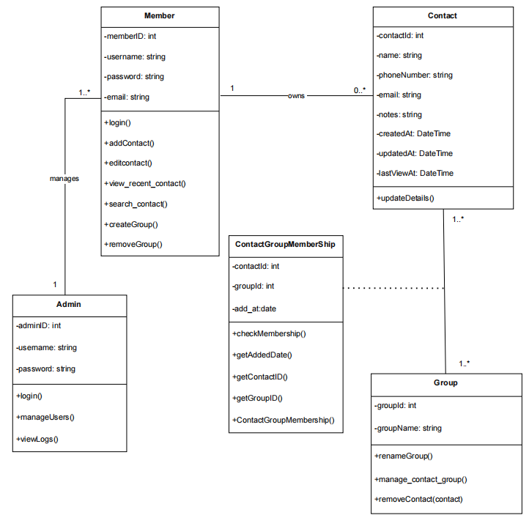
- Database scheme

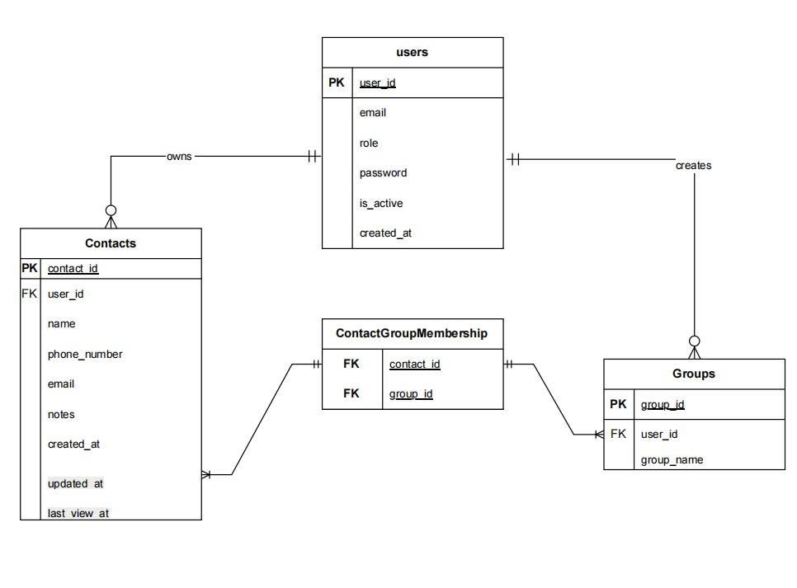

- Document Change Log
